**SDH October growth rate and pasture quality summary (to 28 December 2023)**

After a slower growth period during October, we have seen above average growth for November and December for both the Standard and Lower impact (LI) farmlets. Weather conditions have enabled us to continue with N fertiliser applications to both farmlets with the LI farmlets having received 75% (37.5 kg N) of their annual 50 kg N allowance while the standard farmlets are finishing their 5th applications (105 kg N/ha season to date).

While cumulative growth to date is 6-700 kg DM ahead of the long-term average, for both systems we are slightly behind cumulative growth of the 2022-23 season (Table below).

On the pasture quality front, the 5th round pastures have increased in DM% but are lower in metabolisable energy, driven by much lower non-structural carbohydrates and soluble sugars. Crude protein has remained relatively consistent around 21-22%.

**Table 1: Cumulative pasture growth compared with previous years.**



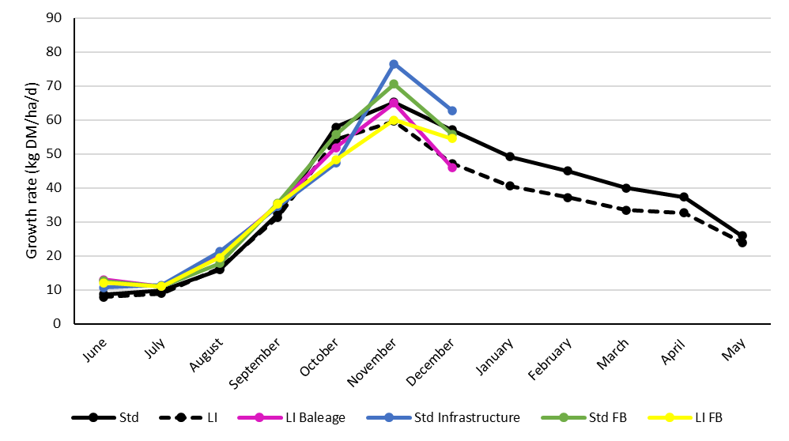 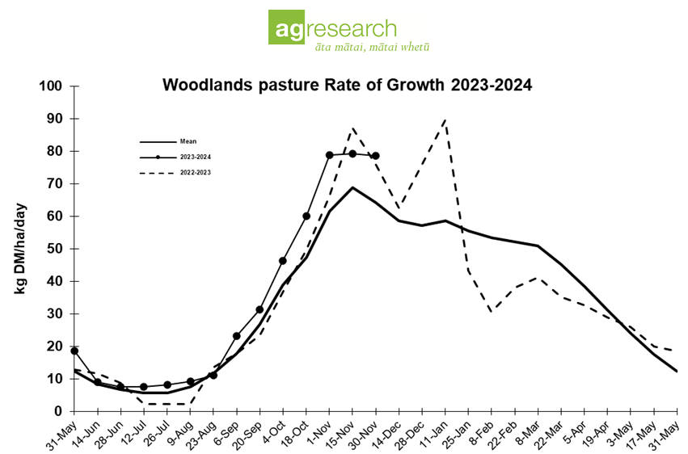

Average monthly pasture growth for the four SDH farmlets and the Woodlands long-term growth rate trial

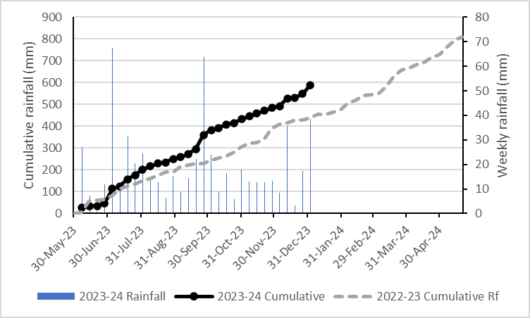

**Pasture quality results**

**Table 2: Pasture quality from standard and lower impact monitor paddocks for each grazing**



**Table 3: Pasture quality from monitor paddocks with and without plantain for each grazing**

