**SDH September growth rate and pasture quality summary (to 26 September)**



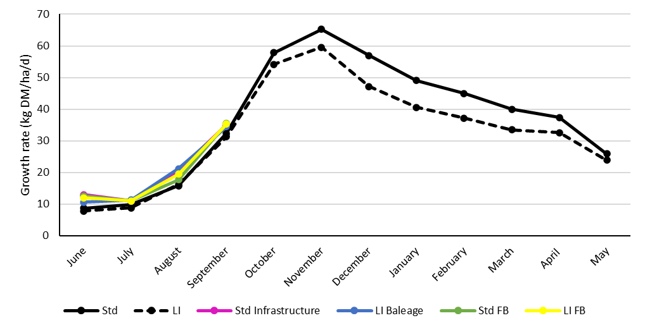

**First round pasture quality results**

