**SDH October growth rate and pasture quality summary (to 31 October)**

Pasture growth continues to be strong across the Std and LI farmlets with net pasture growth being between 170 and 369 kg DM/ha higher season to date than the average of the previous 4 years. At Woodlands the annual growth is 674 kg DM/ha higher this season than their 10 year average. At SDH, except for September, every month since June has had higher average pasture growth (see table below).

The results of the first samples collected from the 3rd round grazings are back from the lab and we are very pleased with the quality of the pasture on offer. ME was above 12 for all paddocks and crude protein between 19 and 21%. There is a lot of variation in DM content driven by pasture species and weather conditions at the time of sampling. Third round plantain pastures sampled so far have averaged 12 % DM and non-plantain pastures 16.5%. Fibre levels are remaining relatively constant which is encouraging given the challenges we have had regarding achieving residuals in many paddocks.



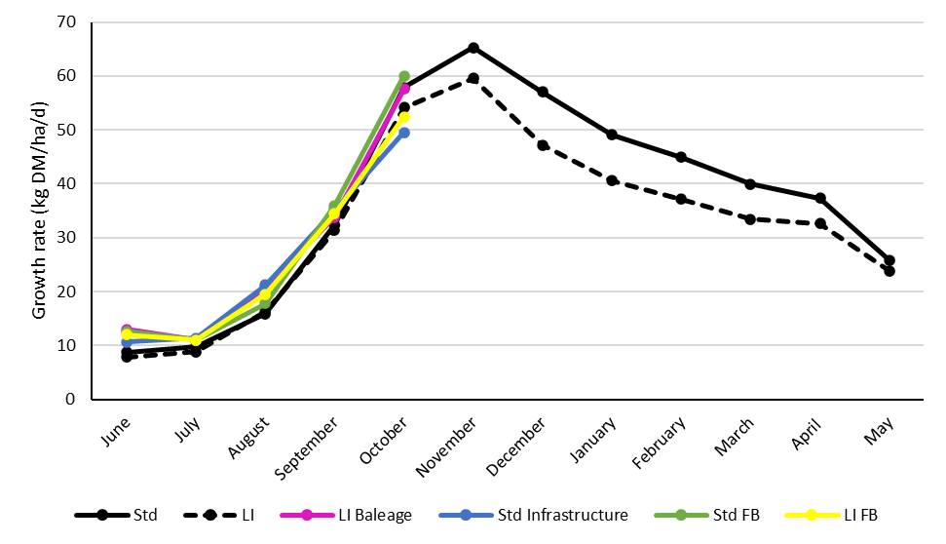 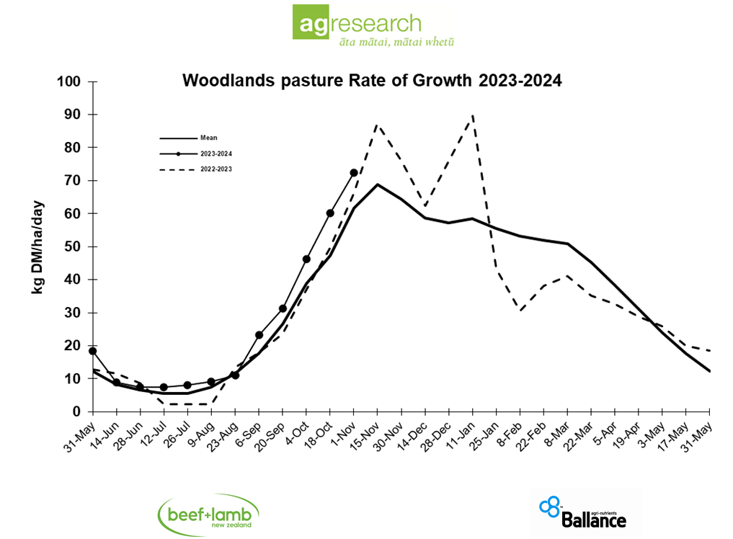

Average monthly pasture growth for the four SDH farmlets and the Woodlands long-term growth rate trial

**Pasture quality results**

